**Excel macro to change onprintshop sales invoice to import into Xero**

**Macro Steps:**

1. Enable the developer ribbon in excel and click Record Macro
2. Delete the 2 rows at the top
3. Change Order No. header to InvoiceNumber
4. Change Order Date header to InvoiceDate
5. Change Customer header to ContactName
6. Delete the User Type column
7. Change Customer Email ID header to EmailAddress
8. Change Product Details header to Description
9. Change Qty header to Quantity
10. Delete Price column
11. Delete Tax column
12. Delete Price With Tax column
13. Delete Shipping column
14. Add new column called UnitAmount
15. Add a formula in the first row of UnitAmount column. Divide Total with Quantity rows
16. Select and autofill to the last row

**Output:**

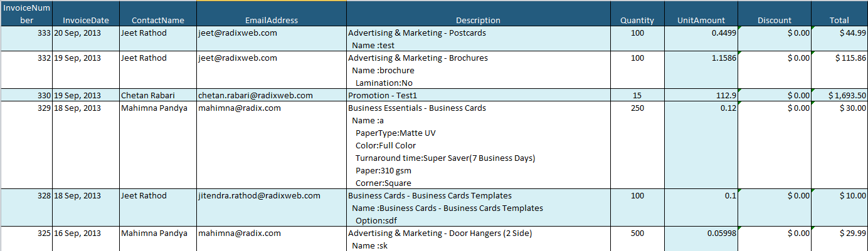

**Some issues with the macro…**

The last step in the macro (autofill to the last record) does not work for invoices with different number of transactions from the invoice that is used to record the macro. I haven’t found a fix to this yet but you can just do the autofill after running the macro (macro can be changed to only edit the first row) by dragging the fill handle to the last row.

**Importing into Xero:**

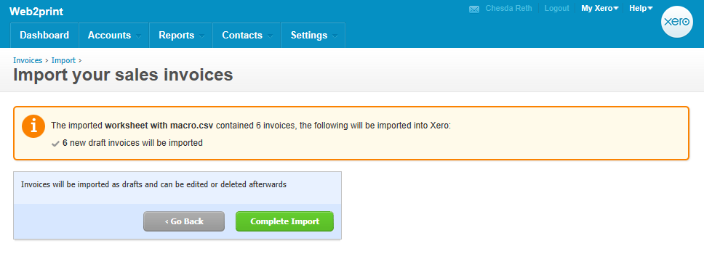

No warning or error notices

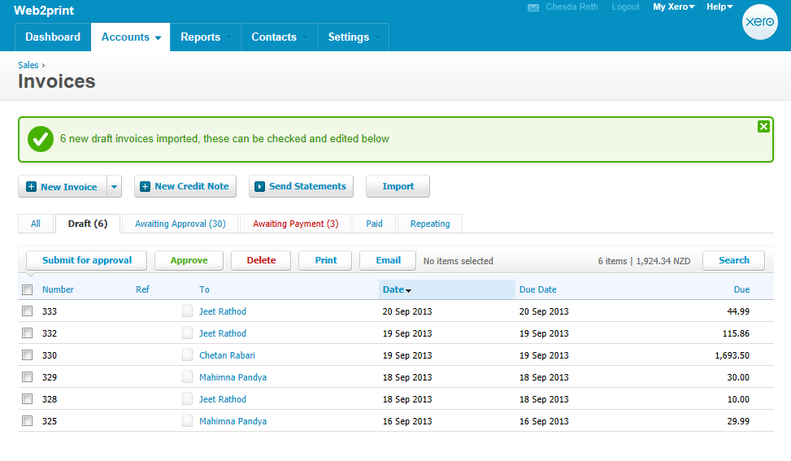The DueDate is set to the same date as the InvoiceDate by default if there is no DueDate in the CSV file import. DueDate is blank in the CSV because OnPrintShop does not have this information when exporting an Invoice.

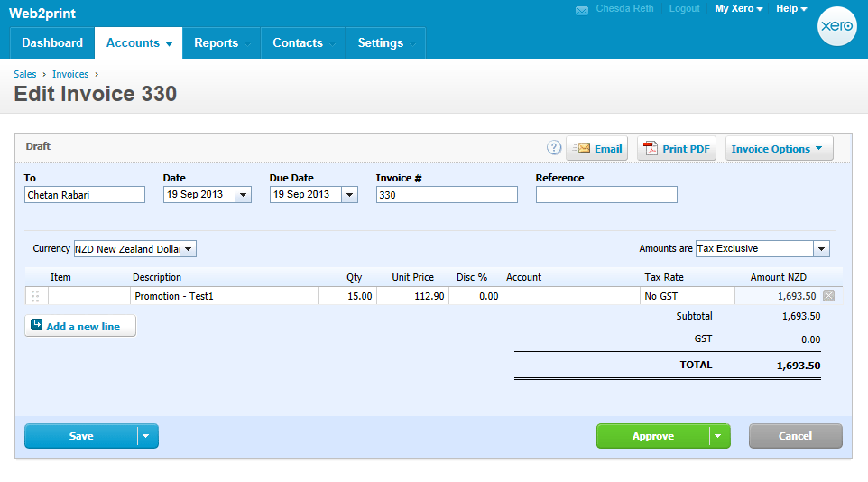

Everything is filled in properly except for the Tax Rate. (Change macro to import GST inclusive price or import prices without tax and let Xero handle the GST calculation??).

Item column is not mandatory – only needed if you want to use the Inventory management system in Xero.

Account column can be blank but there probably needs to be something there to see revenue from sales. If I change this to 200 (default template for invoice) then GST is added to the total cost. Change the CSV to get the price without tax and let Xero add the GST?

PDF copy

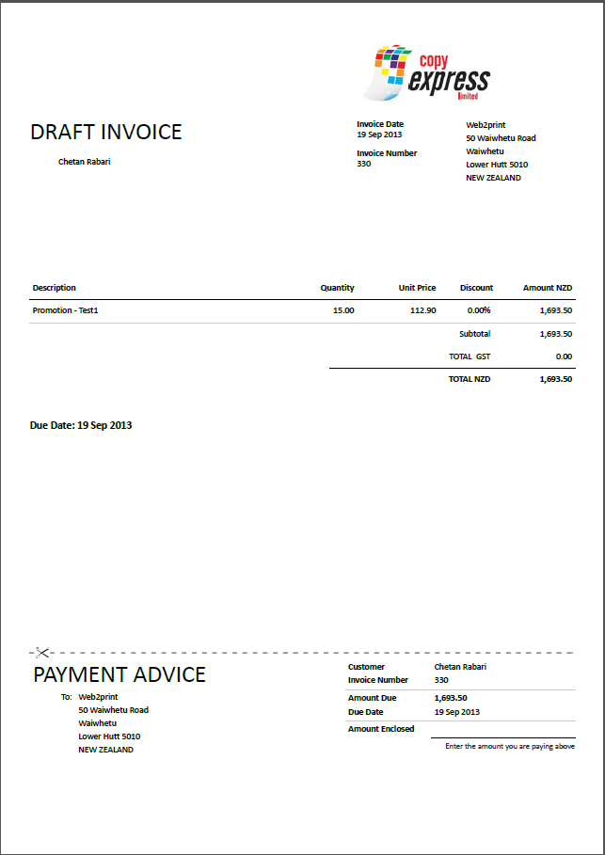

**Macro version2 with account code and GST exclusive total**

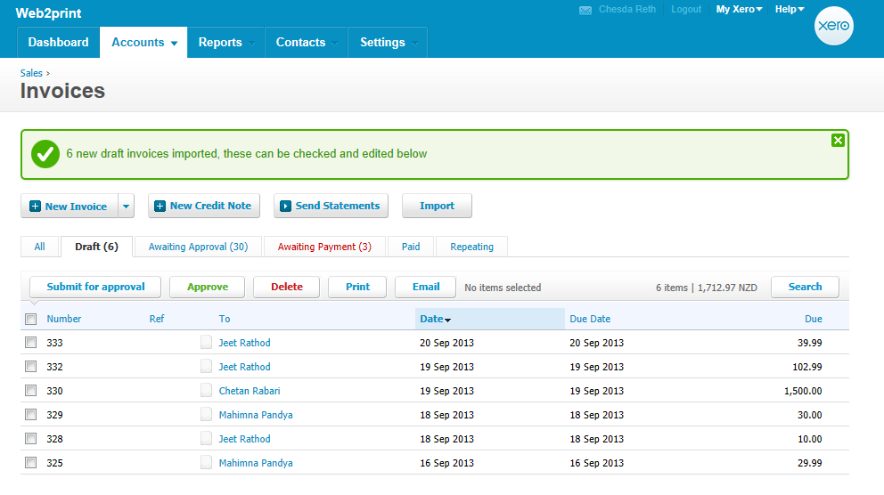

GST is not included even when the Sales account is specified in the CSV file. Need to add in a column for TaxAmount or TaxType in the CSV???

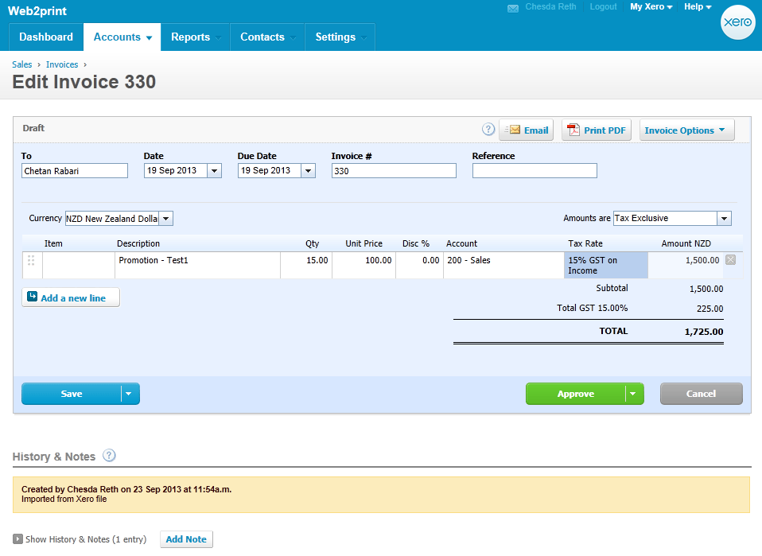

**Macro version3**

Sub CSV()

Dim unitAmount As Long

Dim accountCode As Long

Rows("1:1").Select

Selection.Delete Shift:=xlUp

Selection.Delete Shift:=xlUp

range("A1").Select

ActiveCell.FormulaR1C1 = "InvoiceNumber"

range("B1").Select

ActiveCell.FormulaR1C1 = "InvoiceDate"

range("C1").Select

ActiveCell.FormulaR1C1 = "ContactName"

Columns("D:D").Select

Selection.Delete Shift:=xlToLeft

range("D1").Select

ActiveCell.FormulaR1C1 = "EmailAddress"

range("E1").Select

ActiveCell.FormulaR1C1 = "Description"

range("F1").Select

ActiveCell.FormulaR1C1 = "Quantity"

range("G1").Select

ActiveCell.FormulaR1C1 = "Total"

range("H1").Select

ActiveCell.FormulaR1C1 = "UnitAmount"

range("I1").Select

ActiveCell.FormulaR1C1 = "AccountCode"

Columns("J:J").Select

Selection.Delete Shift:=xlToLeft

Columns("K:K").Select

Selection.Delete Shift:=xlToLeft

'Calculate UnitAmount and autofill to the last row in the column'

range("H2").Select

ActiveCell.FormulaR1C1 = "=RC[-1]/RC[-2]"

unitAmount = Cells(1, Columns.Count).End(xlToLeft).Column

Selection.AutoFill Destination:=range("H2:H" & unitAmount - 3), Type:=xlFillDefault

'Enter account code and autofill to the last row'

range("I2").Select

ActiveCell.FormulaR1C1 = "200"

accountCode = Cells(1, Columns.Count).End(xlToLeft).Column

Selection.AutoFill Destination:=range("I2:I" & accountCode - 3), Type:=xlFillDefault

'Delete last row in spreadsheet'

End Sub

**Change Notes:**

* Now autofills to the last row in UnitAmount column.
* Still working out how to select the last row in the spreadsheet with data.

**Macro version3.1**

Sub CSV()

Dim unitAmount As Long

Dim accountCode As Long

Rows("1:1").Select

Selection.Delete Shift:=xlUp

Selection.Delete Shift:=xlUp

range("A1").Select

ActiveCell.FormulaR1C1 = "InvoiceNumber"

range("B1").Select

ActiveCell.FormulaR1C1 = "InvoiceDate"

range("C1").Select

ActiveCell.FormulaR1C1 = "ContactName"

Columns("D:D").Select

Selection.Delete Shift:=xlToLeft

range("D1").Select

ActiveCell.FormulaR1C1 = "EmailAddress"

range("E1").Select

ActiveCell.FormulaR1C1 = "Description"

range("F1").Select

ActiveCell.FormulaR1C1 = "Quantity"

range("G1").Select

ActiveCell.FormulaR1C1 = "Total"

range("H1").Select

ActiveCell.FormulaR1C1 = "UnitAmount"

range("I1").Select

ActiveCell.FormulaR1C1 = "AccountCode"

Columns("J:J").Select

Selection.Delete Shift:=xlToLeft

Columns("K:K").Select

Selection.Delete Shift:=xlToLeft

'Calculate UnitAmount and autofill to the last row in the column'

range("H2:H" & range("H" & Rows.Count).End(xlUp).Row - 1).FormulaR1C1 = "=RC[-1]/RC[-2]"

'Enter account code and autofill to the last row'

range("I2:I" & range("A" & Rows.Count).End(xlUp).Row - 1).FormulaR1C1 = "200"

'Delete last row in spreadsheet'

End Sub

**Change Notes:**

Changed the range function call to edit the cells instead of using autofill

**Macro version 4.0**

Sub CSV()

Dim unitAmount As Long

Dim accountCode As Long

Dim erow As Long

Dim ecol As Long

Rows("1:1").Select

Selection.Delete Shift:=xlUp

Selection.Delete Shift:=xlUp

range("A1").Select

ActiveCell.FormulaR1C1 = "InvoiceNumber"

range("B1").Select

ActiveCell.FormulaR1C1 = "InvoiceDate"

range("C1").Select

ActiveCell.FormulaR1C1 = "ContactName"

Columns("D:D").Select

Selection.Delete Shift:=xlToLeft

range("D1").Select

ActiveCell.FormulaR1C1 = "EmailAddress"

range("E1").Select

ActiveCell.FormulaR1C1 = "Description"

range("F1").Select

ActiveCell.FormulaR1C1 = "Quantity"

range("G1").Select

ActiveCell.FormulaR1C1 = "Total"

range("H1").Select

ActiveCell.FormulaR1C1 = "UnitAmount"

range("I1").Select

ActiveCell.FormulaR1C1 = "AccountCode"

Columns("J:J").Select

Selection.Delete Shift:=xlToLeft

Columns("K:K").Select

Selection.Delete Shift:=xlToLeft

'Calculate UnitAmount and autofill to the last row in the column'

range("H2:H" & range("H" & Rows.Count).End(xlUp).Row - 1).FormulaR1C1 = "=RC[-1]/RC[-2]"

'Enter account code and autofill to the last row'

range("I2:I" & range("A" & Rows.Count).End(xlUp).Row - 1).FormulaR1C1 = "200"

'Delete last row in spreadsheet'

erow = range("A" & Rows.Count).End(xlUp).Row

ecol = Cells(1, Columns.Count).End(xlToLeft).Column

range(Cells(erow, 1), Cells(erow, ecol)).Delete

End Sub

**Change Notes:**

Deletes last row with Totals

**Macro version 4.1**

Sub CSV()

Dim unitAmount As Long

Dim accountCode As Long

Dim erow As Long

Dim ecol As Long

Rows("1:1").Select

Selection.Delete Shift:=xlUp

Selection.Delete Shift:=xlUp

range("A1").Select

ActiveCell.FormulaR1C1 = "InvoiceNumber"

range("B1").Select

ActiveCell.FormulaR1C1 = "InvoiceDate"

range("C1").Select

ActiveCell.FormulaR1C1 = "ContactName"

Columns("D:D").Select

Selection.Delete Shift:=xlToLeft

range("D1").Select

ActiveCell.FormulaR1C1 = "EmailAddress"

range("E1").Select

ActiveCell.FormulaR1C1 = "Description"

range("F1").Select

ActiveCell.FormulaR1C1 = "Quantity"

range("G1").Select

ActiveCell.FormulaR1C1 = "Total"

range("H1").Select

ActiveCell.FormulaR1C1 = "UnitAmount"

range("I1").Select

ActiveCell.FormulaR1C1 = "AccountCode"

Columns("J:J").Select

Selection.Delete Shift:=xlToLeft

Columns("K:K").Select

Selection.Delete Shift:=xlToLeft

'Calculate UnitAmount and autofill to the last row in the column'

range("H2:H" & range("H" & Rows.Count).End(xlUp).Row - 1).FormulaR1C1 = "=RC[-1]/RC[-2]"

'Enter account code and autofill to the last row'

range("I2:I" & range("A" & Rows.Count).End(xlUp).Row - 1).FormulaR1C1 = "200"

'Delete last row in spreadsheet'

erow = range("A" & Rows.Count).End(xlUp).Row

ecol = Cells(1, Columns.Count).End(xlToLeft).Column

range(Cells(erow, 1), Cells(erow, ecol)).Delete

ChDir "C:\CSV"

ActiveWorkbook.SaveAs Filename:="C:\CSV\invoice.csv", FileFormat:=xlCSV, _

CreateBackup:=False

End Sub

**Change Notes:**

Converts Excel into CSV and saves it into C:\CSV folder

**Macro version 4.2**

Sub CSV()

Dim unitAmount As Long

Dim accountCode As Long

Dim erow As Long

Dim ecol As Long

Dim fileName As String

Rows("1:1").Select

Selection.Delete Shift:=xlUp

Selection.Delete Shift:=xlUp

range("A1").Select

ActiveCell.FormulaR1C1 = "InvoiceNumber"

range("B1").Select

ActiveCell.FormulaR1C1 = "InvoiceDate"

range("C1").Select

ActiveCell.FormulaR1C1 = "ContactName"

Columns("D:D").Select

Selection.Delete Shift:=xlToLeft

range("D1").Select

ActiveCell.FormulaR1C1 = "EmailAddress"

range("E1").Select

ActiveCell.FormulaR1C1 = "Description"

range("F1").Select

ActiveCell.FormulaR1C1 = "Quantity"

range("G1").Select

ActiveCell.FormulaR1C1 = "Total"

range("H1").Select

ActiveCell.FormulaR1C1 = "UnitAmount"

range("I1").Select

ActiveCell.FormulaR1C1 = "AccountCode"

Columns("J:J").Select

Selection.Delete Shift:=xlToLeft

Columns("K:K").Select

Selection.Delete Shift:=xlToLeft

'Calculate UnitAmount and autofill to the last row in the column'

range("H2:H" & range("H" & Rows.Count).End(xlUp).Row - 1).FormulaR1C1 = "=RC[-1]/RC[-2]"

'Enter account code and autofill to the last row'

range("I2:I" & range("A" & Rows.Count).End(xlUp).Row - 1).FormulaR1C1 = "200"

'Delete last row in spreadsheet'

erow = range("A" & Rows.Count).End(xlUp).Row

ecol = Cells(1, Columns.Count).End(xlToLeft).Column

range(Cells(erow, 1), Cells(erow, ecol)).Delete

ChDir "C:\CSV"

myfilename = Left(ActiveWorkbook.Name, InStr(ActiveWorkbook.Name, ".") - 1)

ActiveWorkbook.SaveAs fileName:="C:\CSV\" & myfilename & "_output.csv", FileFormat:=xlCSV, _

CreateBackup:=False

End Sub

**Change Notes:**

Supports multiple files. Saves the CSV file as “filename_output.csv”